**Documentation**

**Project: Gallery**

Author:

Othmane Bakhtaoui

**Gallery - an Individual Project,  
Realidad y Accesibilidad Aumentadas,  
2020.**

**Table of Contents**

**1.** **Description** 3

**1.1.** **Objects that You'll Interact With** 3

**1.2.** **UI Content** 3

**1.3.** **Development Requirements** 4

**2.** **Example Use** 4

**2.1.** **Changing Panels clicking Virtual Buttons** 4

**2.2.** **Changing Panels clicking Voice Command** 5

**2.3.** **Interacting and Moving and Scaling Object** 5

**3.** **Development Process** 6

**3.1.** **Vuforia** 6

**3.2.** **IBM: Text to Speech Algorithm** 7

**3.3.** **Unity Canvas and UI Button** 8

**3.4.** **Lean Unity Asset** 8

**3.5.** **Models** 8

**3.6.** **Main Script** 9

**4.** **References** 9

# **Description**

gallery is a unity educational project used for interacting with 3D objects using STT, Virtual Buttons and Touch-To-Use functionality.

## **Objects that You'll Interact With**

You can add/change/create your own objects and add them to the models but the default in this project are the following:

1. Unity Built-in Objects:
   * Cube.
   * Sphere.
2. External Assets' Objects:
   * Coffee.
   * Donut.
   * Cake.
   * Potion.
   * Crossbow.
   * Pumpkin (because we all love halloween).

## **UI Content**

There are 4 panels used with 2 virtual buttons.

Each panel will contain 2 objects and an object will be shown when you press either of them and not the Non-Red virtual button:

* The first panel will have green colors and you can change between the following objects,
  + Cube
  + Sphere
* The second panel will have blue colors and contains the following objects,
  + Coffee
  + Potion
* The third panel will have orange colors and contains the following objects,
  + Donut
  + Cake
* The fourth panel will have purple colors and contains the following objects
  + Crossbow
  + Pumpkin.

To change the current panel, you can either:

* Click the Red Virtual Button,
* Or, Say in clear words to your microphone the word Change, so that the Speech-To-Text algorithm works correctly and you'll see the word you said in the bottom-left corner of your screen in a white text button.

Also, you can Scale and Rotate and Move the object shown on your phone's touch screen using only two fingers.

## **Development Requirements**

* Vuforia for Unity.
* A valid Vuforia License.
* Unity 2019.4.13f1.
* Vuforia Image Database.
* IBMWatson Speech-To-Text for Unity.
* Android SDK and NDK.
* JDK.

# **Example Use**

## **Changing Panels clicking Virtual Buttons**



## **Changing Panels clicking Voice Command**



## **Interacting and Moving and Scaling Object**



# **Development Process**

Development content and how this project was done.

## **Vuforia**

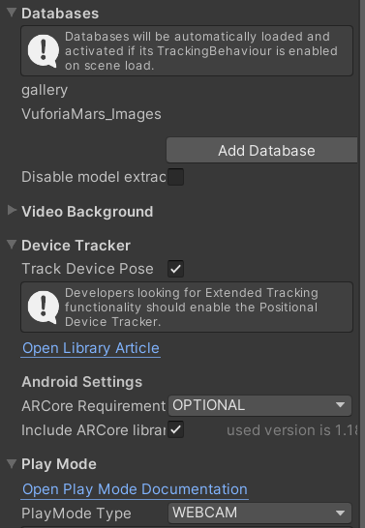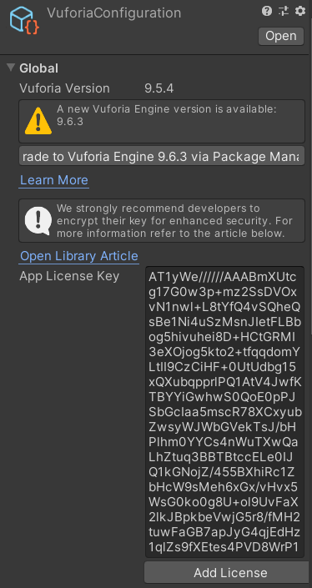First of all, I had to install Vuforia as unitypackage for unity and pick an [image database](https://raw.githubusercontent.com/othub/gallery/master/Assets/Images/cq5dam.web.1280.1280.jpeg) in order to project the objects and to interact with them. The configuration in unity is the following:

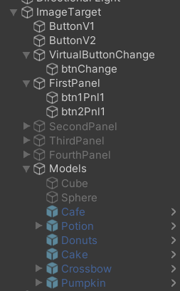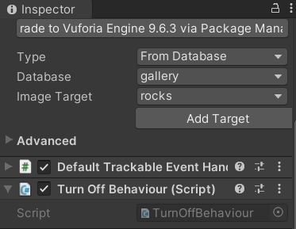Then, you create the ARCamera Vuforia Object and you add to it a Script “**CameraFocusController.cs**” to focus on the object which is the image database. After, create an object called ImageTarget and add to it the image database from Vuforia and your objects (panels, buttons, text).

## **IBM: Text to Speech Algorithm**

Second, I had to install IBM Watson algorithm for text to speech in order to change the panels using “change” command. The steps are the following:

1. Change the build settings in Unity (File > Build Settings) to any platform except for web player/Web GL. The IBM Watson SDK for Unity does not support Unity Web Player.
2. If using Unity 2018.2 or later you'll need to set Scripting Runtime Version and Api Compatibility Level in Build Settings to .NET 4.x equivalent. We need to access security options to enable TLS 1.2.
3. Create an IBMWatson account, and go to services, Speech To Text, and copy the api key and data in order to use it.
4. You can get the latest SDK release by clicking [here](https://github.com/watson-developer-cloud/unity-sdk/releases/tag/v4.8.0). You will also need to download the latest release of the IBM Unity SDK Core by clicking [here](https://github.com/IBM/unity-sdk-core/releases/tag/v1.2.1).
5. Move the unity-sdk and unity-sdk-core directories into the Assets directory of your Unity project. Optional: rename the SDK directory from unity-sdk to Watson and the Core directory from unity-sdk-core to IBMSdkCore.
6. Create IBMWatson object and add to It the Script “**ExampleStreaming.cs**” from unity-sdk, adding the panels objects that will be changed using voice command and then update the parameters to match yours in Unity as the following:

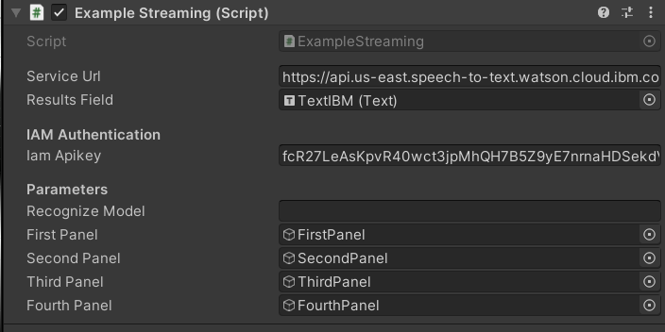

## **Unity Canvas and UI Button**

I had to add a Canvas to show the Speech To Text value from the “**ExampleStreaming.cs**” script in a UI button text.

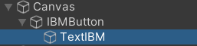

## **Lean Unity Asset**

Thirdly, I’ve found a unity asset that can be used to interact with objects called “Lean”, it has various scripts but the one I’m using is “**LeanTouch.cs**” for the models (cube, sphere,…) in order to interact with them and “**LeanTwistRotate.cs**” in order to rotating and scaling and twisting said objects. All params are default.

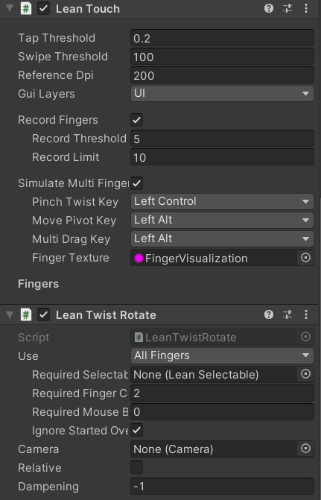

## **Models**

As default, the models (cube, sphere and external assets) are disabled because I wanted to show a clean canvas, also, only the first panel is enabled because it will be changed by the user when clicking a VButton or using Voice Command.

## **Main Script**

Finally, the main script to change panels and objects is “**VBInteraction.cs**”, the parameters are passed the in Inspector, Panels and Objects. And The same logic in this script is copied in the “**ExampleStreaming.cs**” of IBMWatson. It basically activates an object and hides the others.

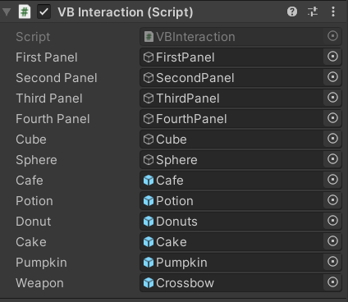

# **References**

References and tutorials to configure the project.

Vuforia, License: <https://www.youtube.com/watch?v=ETAnttef7Zw>

Configuring IBM for Unity: <https://github.com/watson-developer-cloud/unity-sdk>

IBMWatson: <https://www.youtube.com/watch?v=FgjkqEkcrbA>

Vuforia Virtual Buttons: <https://www.youtube.com/watch?v=Fgd21lbhikU>

Lean touch: <https://www.youtube.com/watch?v=gxaWaiVn1bs>